# Prometheus monitoring for Java application

## Setup Push Gateway (Using the same setup as python app)

I’ve used docker for simplicity

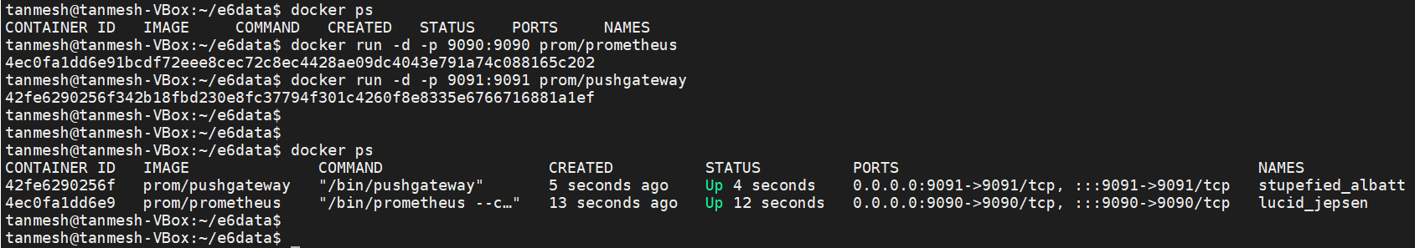

### Check whether prometheus and pushgateways are accessible from browser

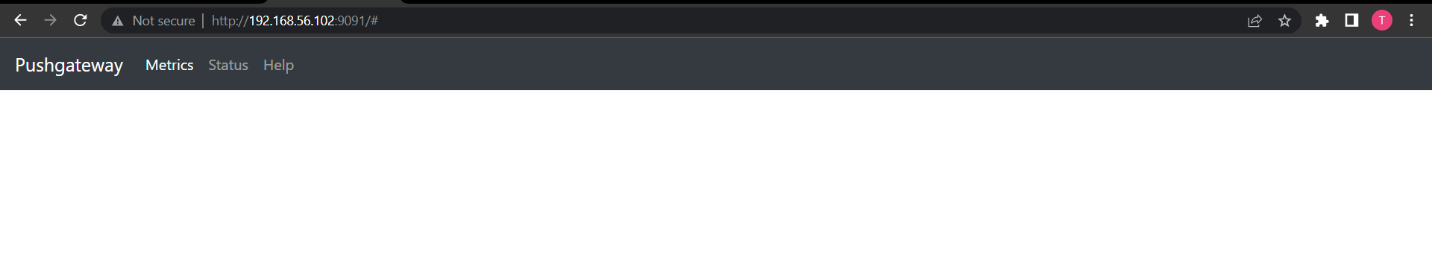

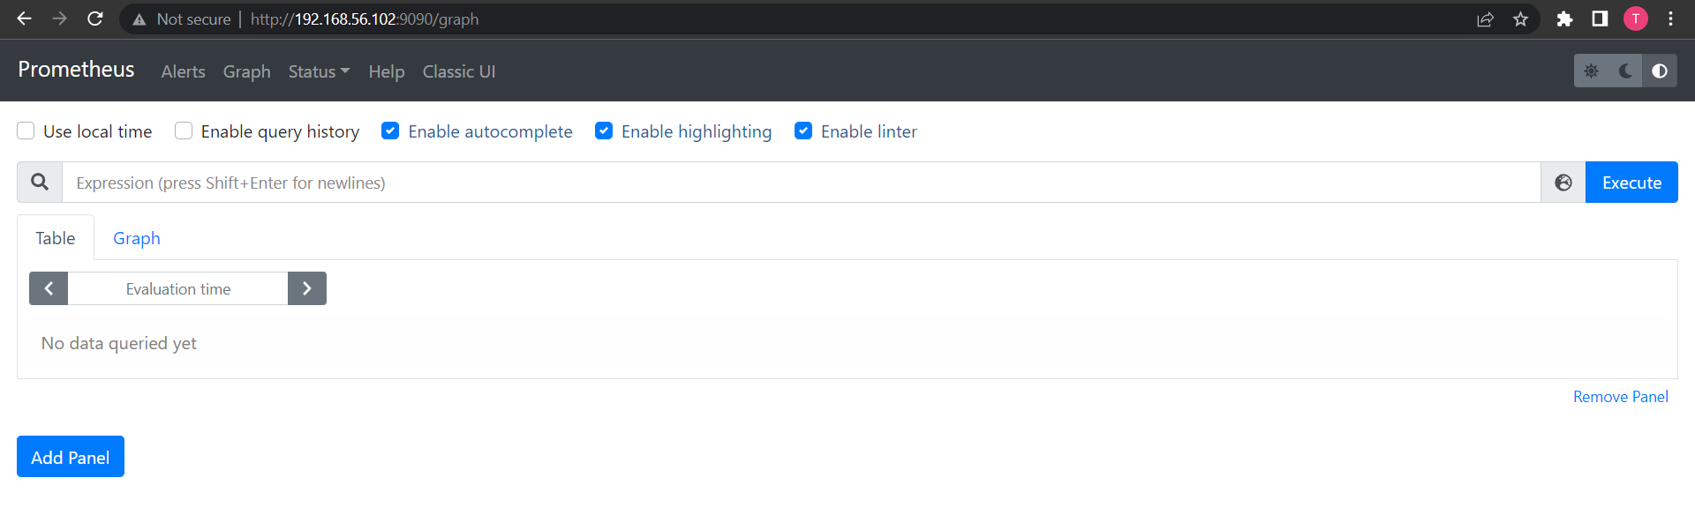

### Prometheus configs

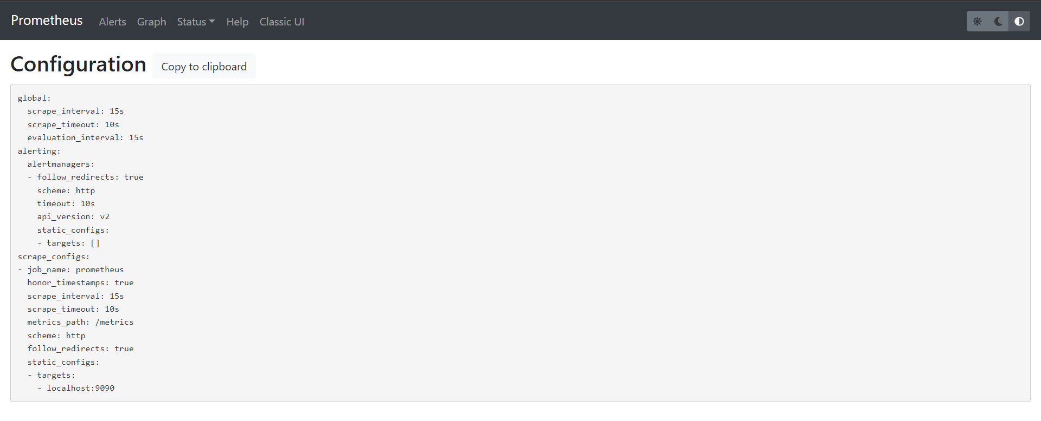

### Now configure Prometheus.yaml file for pushgateway

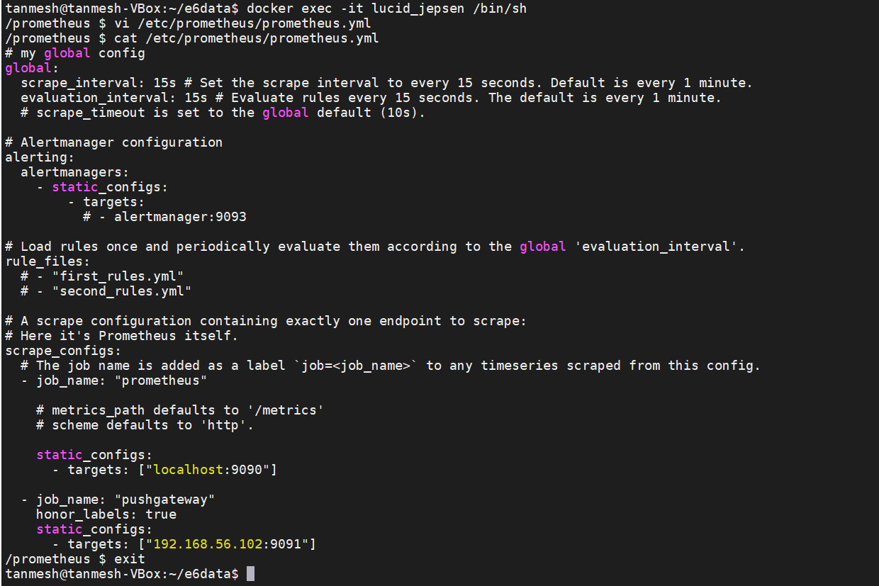

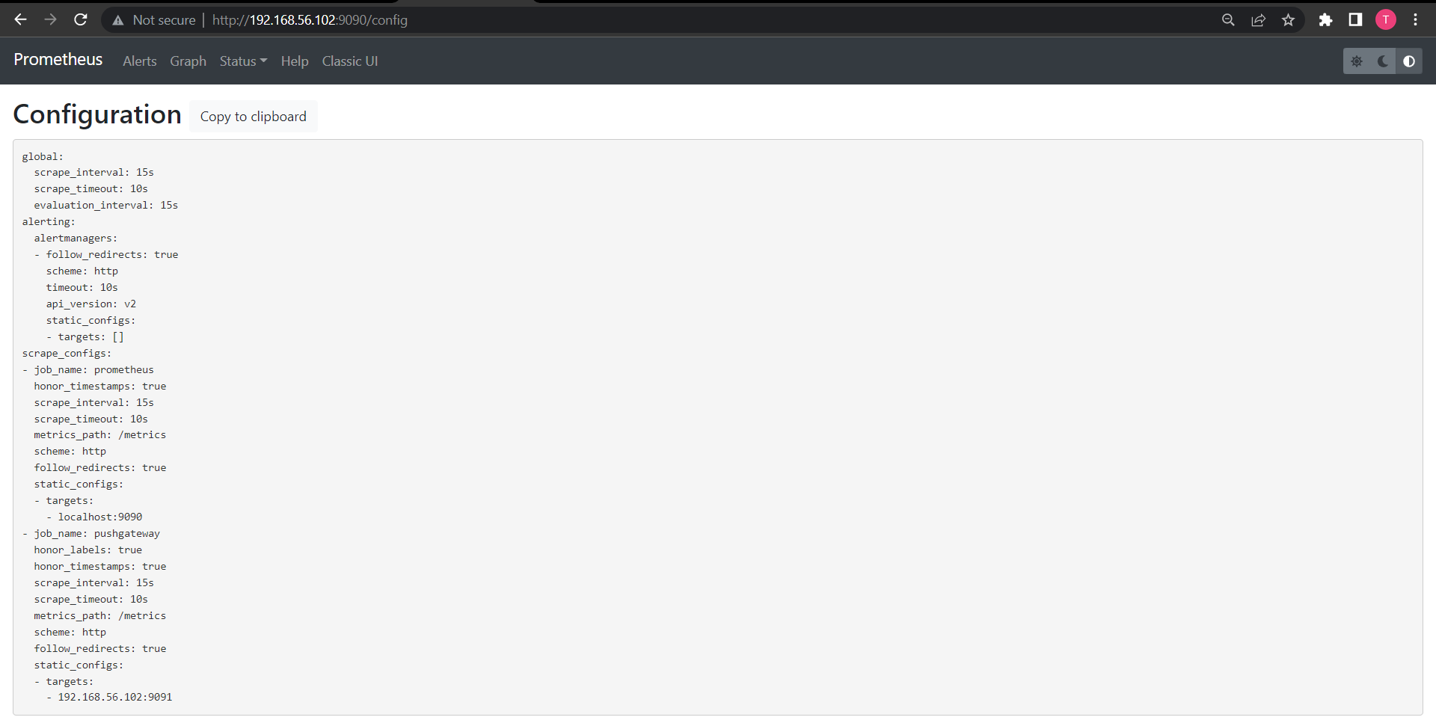

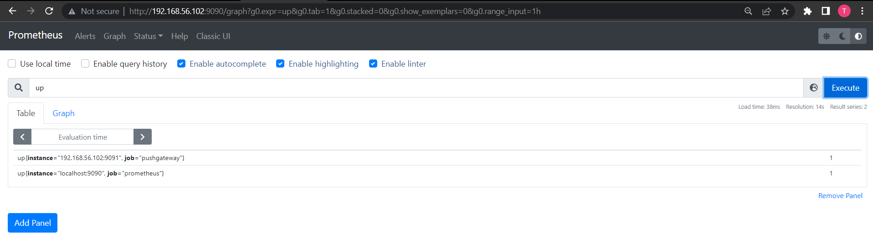

**Directory structure**

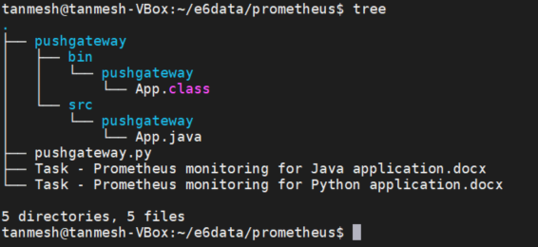

## Java app to push metrics into pushgateway

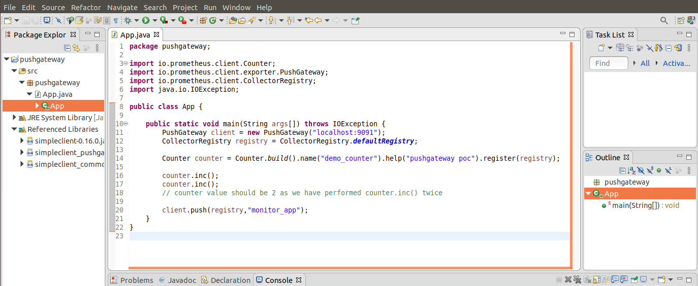

### Pushgateway UI

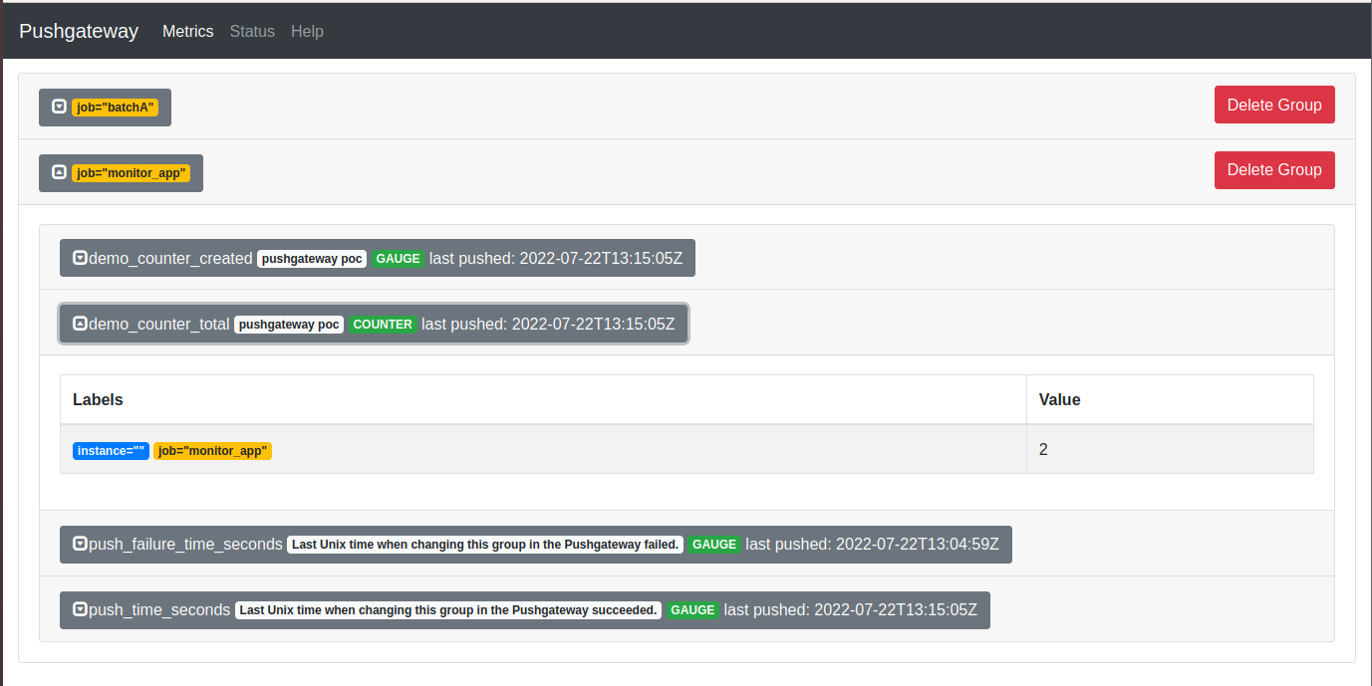

### Prometheus UI

